**Name:_______________________________________ Date:___________Period:_______**

**BioBoost Review-Scientific Method**

**Unveiling Nature's Secrets: A Journey Through the Scientific Method in Plant Growth**

**Introduction:** The scientific method is a powerful tool that scientists use to unravel the mysteries of the natural world. It is not just a step-by-step process; it is a mindset, a way of thinking that enables us to explore and understand the intricacies of the universe. By following a systematic approach, scientists can uncover patterns, make predictions, and contribute to the vast body of knowledge that spans across various disciplines.

**Importance of the Scientific Method:** The scientific method provides a structured framework for inquiry, ensuring that investigations are conducted in a logical and unbiased manner. It promotes critical thinking and encourages curiosity, guiding researchers in their pursuit of answers to questions that arise from keen observations. Without the scientific method, our understanding of the world would be limited, and progress in fields such as medicine, technology, and environmental science would be hindered.

**Historical Examples of Scientific Method Success:** Throughout history, the scientific method has played a crucial role in groundbreaking discoveries. One notable example is the work of Sir Isaac Newton, who applied the scientific method to formulate the laws of motion and universal gravitation. These principles revolutionized our understanding of physics and laid the foundation for subsequent scientific advancements.

Another compelling instance is the development of the germ theory of disease in the 19th century. Scientists like Louis Pasteur and Robert Koch meticulously followed the scientific method to demonstrate the link between microorganisms and infectious diseases. This breakthrough had profound implications for public health, leading to improvements in sanitation practices and the development of vaccines.

Figure :Louis Pasteur Rendition

In more recent times, the application of the scientific method has been instrumental in addressing environmental challenges. Climate scientists, for instance, use rigorous experimentation and data analysis to understand the complex interactions within Earth's climate system, contributing to our ability to predict and mitigate climate change.

**Overview of the Scientific Method:** The scientific method involves a series of steps, each building upon the other. It begins with observations, where scientists keenly observe natural phenomena and identify interesting patterns or questions. From these observations, questions emerge, prompting the formulation of hypotheses – educated guesses about potential explanations.

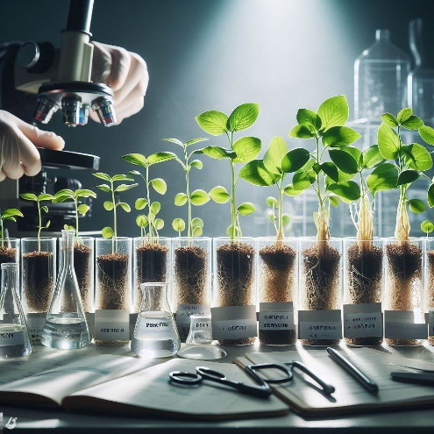Experiments are then designed to test these hypotheses, with careful consideration given to controlling variables and minimizing bias. Data is collected and analyzed, leading to conclusions that either support or reject the initial hypothesis. Through this process, scientific knowledge evolves, refining our understanding of the world.

As we embark on a journey through the scientific method in the context of plant growth, we will witness the application of these principles to unravel the mysteries of how plants respond to different substances, such as water and fertilizer.

1. **Question:** What is emphasized as the key mindset behind the scientific method in the introduction?
2. **Question:** How does the scientific method contribute to progress in various fields, according to the introduction?
3. **Question:** Can you name one historical example mentioned in the text where the scientific method played a crucial role in a groundbreaking discovery?
4. **Question:** In what way does the scientific method encourage researchers, as mentioned in the introduction?
5. **Question:** According to the text, what is the significance of the germ theory of disease in the 19th century, and how was the scientific method involved in its development?

**Understanding the Scientific Method in Plant Growth**

**Introduction:** The scientific method is a systematic way scientists investigate and explore the world around them. It consists of several steps that help researchers make observations, form hypotheses, conduct experiments, and draw conclusions.

**Overview of the Scientific Method:** The scientific method involves the following steps:

1. **Observation:** Noticing something interesting or puzzling in the natural world.
2. **Question:** Formulating a question based on the observation.
3. **Hypothesis:** a proposed explanation for the way the natural world functions.
4. **Experiment:** Conducting an experiment to test the hypothesis.
5. **Data Collection:** Gathering information and recording observations during the experiment.
6. **Analysis:** Analyzing the data to draw conclusions.
7. **Conclusion:** Determining whether the hypothesis was supported or rejected.

**Applying the Scientific Method to Plant Growth:** Let's explore each step in detail using an example of grouping plants with water versus fertilizer.

1. **Observation:** Plants seem to grow differently when given either water or fertilizer.
2. **Question:** How does the type of substance given to plants affect their growth?
3. **Hypothesis:** If plants are given water, they will grow differently than if they are given fertilizer because the fertilizer contains the nutrients necessary for plant growth.
4. **Experiment:** Plant two groups of identical plants, one group receiving only water and the other only fertilizer.
5. **Data Collection:** Measure the height, number of leaves, and overall health of each group of plants over a specified period.
6. **Analysis:** Compare the data collected from the water group and the fertilizer group to see if there are any significant differences.
7. **Conclusion:** Determine whether the hypothesis was supported based on the observed differences in plant growth.

**Other Key Terms Used in the Scientific Method:**

* **Independent Variable:** The variable that is deliberately **changed** in an experiment (e.g., the type of substance given to plants).
* **Dependent Variable:** The variable that isobserved and **measured** in response to changes in the independent variable (e.g., plant growth).
* **Control:** The group in an experiment that does not receive the experimental treatment, used as a baseline for **comparison**.
* **Constant:** Factors in an experiment that remain **unchanged** to ensure a fair test.
* **Bias:** Prejudice or favoritism that may affect the outcome of an experiment.
* **Hypothesis:** An educated guess or prediction that can be tested through experimentation.
* **Theory:** A well-substantiated explanation based on evidence and repeated testing.
* **Law:** A statement that describes a consistent and universal phenomenon observed in nature.
* **Belief:** A personal conviction that is not necessarily based on scientific evidence.

**Questions:**

1. What is the first step of the scientific method?
2. Why is forming a hypothesis important in the scientific method?
3. Define the independent variable in a scientific experiment.
4. How does the control group contribute to an experiment's validity?
5. What is a constant, and why is it essential in experiments?
6. Explain the difference between a hypothesis and a theory.
7. Provide an example of an observation related to plant growth.
8. Why is it important to avoid bias in scientific experiments?
9. Define the dependent variable in the context of plant growth.
10. Distinguish between a scientific law and a scientific theory.