Name:__________________________________________________ Period:______ Date:_____ Score:_______

Thermodynamics Lab

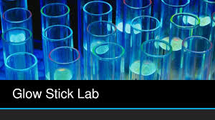

|  |
| --- |
| **NGSS Standard(s):**   * **HS-PS3-4** Plan and conduct an investigation to provide evidence that the transfer of thermal energy when two components of different temperature are combined within a closed system results in a more uniform energy distribution among the components in the system (second law of thermodynamics). * **PS3.B:** Conservation of Energy and Energy Transfer. Energy cannot be created or destroyed, but it can be transported from one place to another and transferred between systems. Uncontrolled systems always evolve toward more stable states—that is, toward more uniform energy distribution (e.g., water flows downhill, objects hotter than their surrounding environment cool down). * **PS3.D:** Energy in Chemical Processes. Although energy cannot be destroyed, it can be converted to less useful forms—for example, to thermal energy in the surrounding environment. |

**I. Introduction:**

The laws of thermodynamics describe the relationships between thermal energy, or heat, and other forms of energy, and how energy affects matter. The **First Law of Thermodynamics** (Law of Conservation of Energy) states that energy cannot be created or destroyed; it only transforms from one kind to another. For example, burning wood. When you burn wood at a campfire, chemical energy gets converted to thermal energy; the chemical reaction that turns wood into ash releases energy in the form of heat.The **Second Law of Thermodynamics** is about the quality of energy. It states that as energy is transferred or transformed, more and more of it is wasted. The Second Law also states that there is a natural tendency of any isolated system to degenerate into a more disordered state. In plants, photosynthesis is the process of using light energy to convert into chemical energy to supply plants with energy. In other organisms, the process of cellular respiration does a similar function. In this lab, you will test the relationship of energy and water temperature to reflect upon 1st and 2nd Law of Thermodynamics.

**II. Hypothesis:**

**“Predict the outcome of submerging glow sticks into various water temperatures. Be specific with your predictions.”**



**III. Material:**

• (3) glass beakers:

• (3) glow sticks (same size, brand, and color)

• Thermometer

• Stopwatch/ timer

**IV. Lab Procedure:**

1. Label each beaker A, B, and C
2. Fill Beaker A with 200 ml of cold water
3. Fill Beaker B with 200 ml of room temperature water
4. Fill Beaker C with 200 ml of hot water
5. Take and record the water temperature of each beaker onto the data table
6. **Teacher/instructor role:** Once all students have recorded water temperature data, teacher will set time for 2 mins and announce to students that when the lights are turned off, they will snap all three the glow sticks and vigorously shake for 5 seconds and then drop one glow stick per beaker and rank each beaker’s brightness.
7. **Student role**: when instructed by teacher, snap all three glow sticks and vigorously shake to mix the chemical solution together for 5 seconds and drop one glow stick into the labeled beaker.
8. Rank the brightness level of each beaker:

* 1: Brightest
* 2: Somewhat Bright
* 3: Least Bright (Dimmest)

1. Record the time of when each beaker was at its brightest and decreased in brightness

**V. Use the lab to complete the following data table.**

|  |  |  |  |  |
| --- | --- | --- | --- | --- |
|  | Water temperature | Brightness level | Time when brightness level reached | Time when brightness level decreased |
| **Beaker A** |  |  |  |  |
| **Beaker B** |  |  |  |  |
| **Beaker C** |  |  |  |  |

**VI. Graph your findings:**

**VII. Lab Report:**

1. Read the following article “[How Glow Sticks Work](https://www.thoughtco.com/how-do-lightsticks-work-607878)” to find evidence to support your lab experiment and complete the bucket filler graphic organizer: <https://www.thoughtco.com/how-do-lightsticks-work-607878>

Use facts from the article to fill the droplets for the bucket of facts. 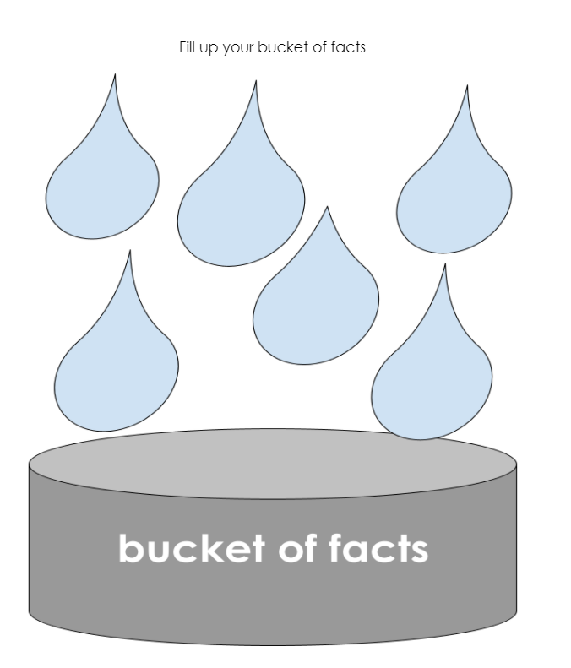

Describe your findings and conclusions

______________________________________________________________________________________________________________________________________________________________________________________________________________________________________________________________________________________________________________________________________________________________________________________________________________________________________________________________________________________________________________________________________________________________________________________________________________________________________________________________________________________________________________________________

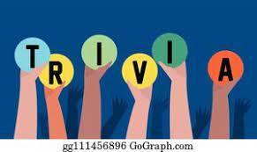

1. True or False: A measure of energy transfer that occurs when an object is moved over a distance by an external force is known as heat.
2. True or False: A closed system is a system that has external interactions, such as energy transfers into or out of the system boundary.
3. True or False: The transformation of chemical energy into kinetic and heat energy by a car engine is a manifestation of the first law of thermodynamics.