Name:___________________________________________________ Date:_______ Period:_________

**pH Exploration Lab**

**Background:** Acidity or alkalinity (basic) is a measure of the relative amount of H+ (hydrogen) ions and OH- (hydroxide) ions dissolved in a solution. Neutral (pH of 7) solutions have an equal number of H+ and OH- ions. Acids (pH below 7) have more H3O+ ions (H+) than OH- ions. Acids taste sour (think lemon juice) and can be corrosive. Digestive fluids in the body are acidic and must be neutralized by buffers especially as the stomach juices enter the small intestine. Bases (pH above 7) contain more OH- ions than H3O+ ions. Bases taste bitter and feel slippery.

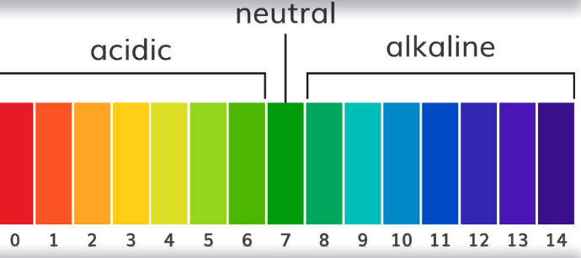

In living things, maintaining proper pH levels is extremely important to an organism’s survival. In a human’s stomach, the digestive juices are acidic and must be neutralized by **buffers** when the stomach contents enter the small intestine. Without the buffers your small intestine would be damage by the acidic stomach contents. Aquatic organisms like fish are sensitive to changes in pH. Pollutants like excessive carbon dioxide in the atmosphere could interact with the water it can cause changes in pH and cause the fish or other aquatic organisms to die.

In this activity you will practice determining the pH of common household products. You will test five different items.

Materials:

* Pipette
* pH test strip or other indicator (directions may vary depending on the type of test strip being used)
* Petri dish
* At least 5 household products with varying pH

Directions:

1. Gather your materials and listen to the teacher’s directions.
2. Label and place a title heading on the data table.
3. Place one test strip in the clean dry petri dish.
4. Obtain a sample of the solution you wish to test.
5. Use a pipette to place two drops of solution on the test strip.
6. Wait 15 seconds (time may vary depending on the type of test strip) and compare the color of the test strip to the color chart provided with your test strips.
7. Record your data the table below:

Title:

|  |  |
| --- | --- |
|  |  |
|  |  |
|  |  |
|  |  |
|  |  |
|  |  |

Clean up – clean the petri dish, throw the pH strips and paper towels away, rinse out the solutions and pipets.

Questions:

1. What does alkalinity mean?

basic

1. What is the name for the OH- ions?

Hydroxide ions

1. What is the name for the H+ ion?

Hydrogen ions

1. Which substance was the most acidic?

Answers will vary

1. Which substance had the most H+ ions?

Answers will vary (should be the same as #4)

1. Which substance was most basic?

Answers will vary

1. Which substance had the most OH- ions?

Answers will vary (should be the same as #6)

1. Where any of the solutions you tested neutral? If so, which one(s)?

Answers will vary (distilled water if used)

1. Were the physical **observations** you made quantitative or qualitative? Explain.

Qualitative since the we observations. The observation (color) where then quantified used the pH chart.

1. Was the data you recorded into the data table quantitative or qualitative? Explain.

Quantitative, since numerical values were obtained from the use of a measurement tool (pH chart and strips).