Punnett Square Group Challenge

Complete the following Punnett Square problems on the table using chalk or paper. When your group agrees, the answer is correct, raise your hand and your teacher will come check your answers. Be sure all members of the group can explain the answer.

Problem 1:

In humans, being a tongue roller (R) is dominant over non-roller (r). A man who is a non-roller marries a woman who is heterozygous for tongue rolling. **Identify the phenotypic and genotypic ratios of the offspring.**

Problem 2:

A group of students wanted to determine how the ability to taste PTC, a nontoxic chemical, is passed from one generation to the next. The students decided to test families in their community for this ability. The students gave each family member a paper strip coated with a small amount of PTC. Those who experienced the bitter taste of PTC when they touched the paper strips to their tongues were called "tasters"; those who could not taste the PTC were called "nontasters."

The results of the experiment are shown in the table below.

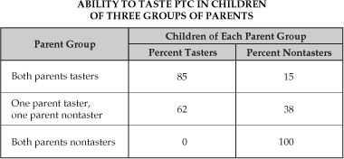

Complete a Punnett Square for Each of the situations above “Both tasters,” “One taster, one nontaster,” “Both nontaster.” Give the genotypic and phenotypic ratios for the offspring each cross.

Problem 3:

Coat color in mice is incompletely dominant. Yellow and white-colored mice are homozygous, while cream-colored mice are heterozygous. If two cream-colored mice mate, what phenotypic ratio can we expect of their offspring? Show the Punnett Square.

Problem 4:

Two parents think their baby was switched at the hospital. Its 1968, so DNA fingerprinting technology does not exist yet. The mother has blood type “O,” the father has blood type “AB,” and the baby has blood type “B.”

* Was the baby switched at the hospital?
* Create Punnett square showing all possible genotypes for children produced by this couple

Resource:

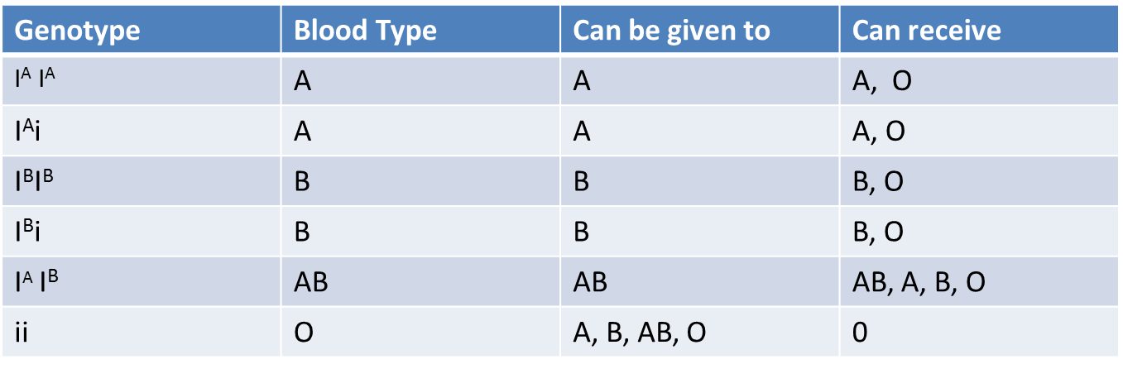

Problem 5:

A pea plant that is heterozygous for both roundness and tallness is crossed with a pea plant that is wrinkled short. What are the chances that these two pea plants will have offspring that are wrinkled and tall? Show your work.

Problem 6:

You are the director of the local orphanage. Lately, 8 couples have come forward claiming to be the real parents of one of your children since she has just inherited a large sum of money. You are not sure what to do so you order each couple and their parents to have their blood types determined. The results are on the next page. Who are the real parents? You need to prove it using Punnett Squares.

Little Orphan Annie –Type O blood

Couple History

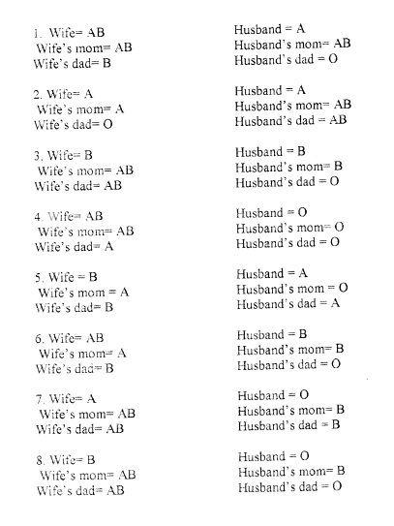

|  |  |
| --- | --- |
| Homework Pass  Room:  Teacher:___________  Student:_____________  Some homework assignment may not be eligible for exemption | Homework Pass  Room:  Teacher:___________  Student:_____________  Some homework assignment may not be eligible for exemption |
| Homework Pass  Room:  Teacher:___________  Student:_____________  Some homework assignment may not be eligible for exemption | Homework Pass  Room:  Teacher:___________  Student:_____________  Some homework assignment may not be eligible for exemption |
| Homework Pass  Room:  Teacher:___________  Student:_____________  Some homework assignment may not be eligible for exemption | Homework Pass  Room:  Teacher:___________  Student:_____________  Some homework assignment may not be eligible for exemption |
| Homework Pass  Room:  Teacher:___________  Student:_____________  Some homework assignment may not be eligible for exemption | Homework Pass  Room:  Teacher:___________  Student:_____________  Some homework assignment may not be eligible for exemption |