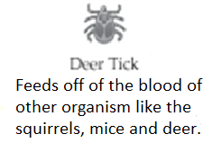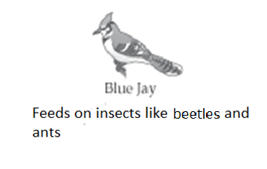

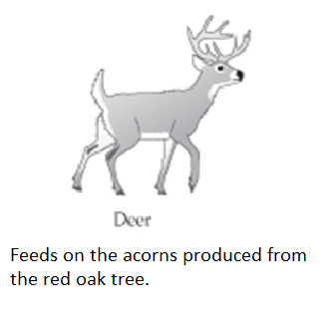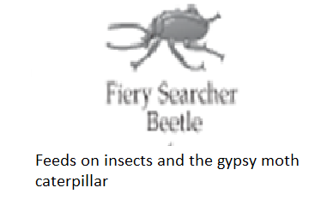

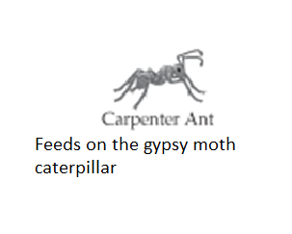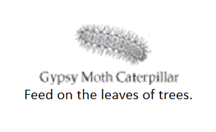

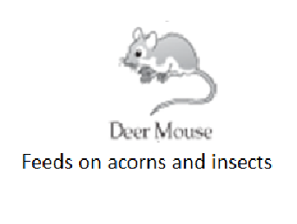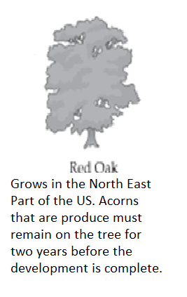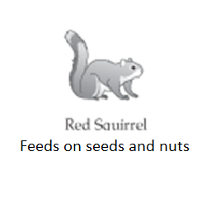

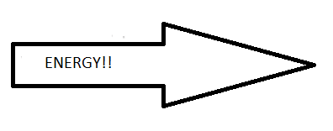

[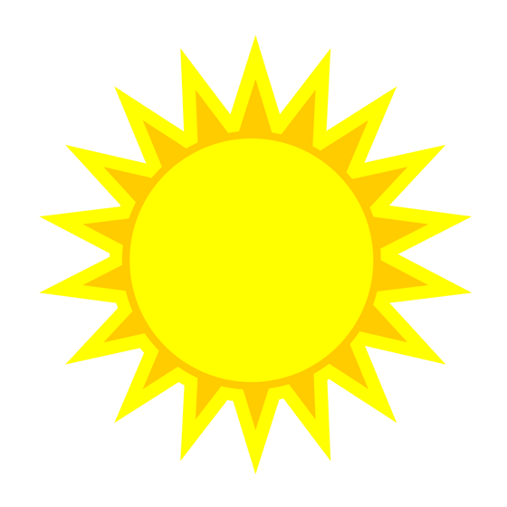](http://www.google.com/url?sa=i&rct=j&q=&esrc=s&source=images&cd=&cad=rja&uact=8&ved=0CAcQjRxqFQoTCLj6gtqj6MgCFQF1Pgodk0AL8w&url=http://www.accentblinds.ca/beat-the-heat-with-sun-screen-shades/&psig=AFQjCNETBYCp3yu6OPfgiKFXH4NLFoBVlg&ust=1446228648131007) 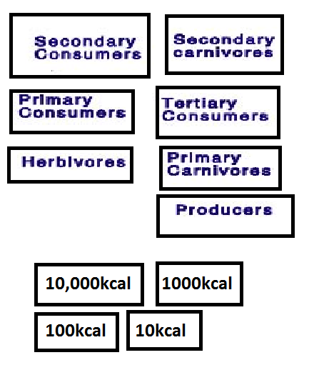

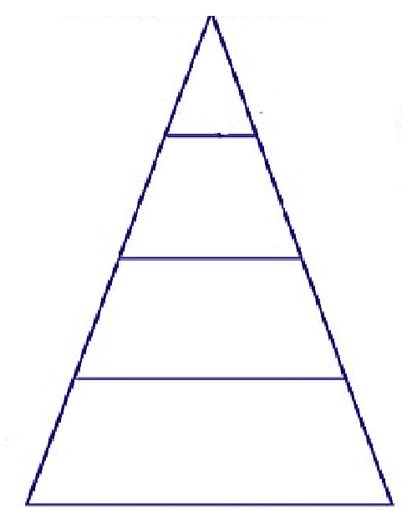

Student Worksheet

Name: _______________________________________________Date:______________

Part 1: Using the sun, organisms and energy arrows provided create a food web. When you have completed the food web, draw the food web using the organism names in the space below. You do not have to draw the organism pictures.

Part 2: In the diagram you drew above, identify the following organism relationships by underlining the organisms name using a specific color.

Autotroph(s)-green Heterotroph(s)- brown herbivore(s)-orange

Carnivore(s)-red Omnivore(s)-blue

Producer(s) –pink Consumer(s)-yellow

Part 3: Identify the relationship of the organisms listed below. Word bank (mutualism, commensalism, parasitism, competition, producer-consumer)

A deer eating an acorn:__________________________

A cleaner fish feeding off of the particle of fish left in a shark’s mouth :____________________

A squirrel and a chipmunk gather acorns for the winter:____________________________

A tick feeding on a mouse: _______________________

Nitrogen fixing bacteria make nitrogen available for trees and the tree provides the bacteria with nutrients:__________________________

Part 4: In the food web you built, describe what would happen to the population of the other organisms if the deer population decreased significantly. Use a (+) to indicate an increase in population, (-) to indicated a decrease in population and (=) if there would be no change in the population.

Part 5: Using the organisms from the foodweb, the energy numbers (kcal), pyramid, and vocabulary terms, arrange the organism and terms into the pyramid in the correct location. Remember in an energy pyramid 10% of the energy makes it to the next level. When you complete the activity, record your results below.

