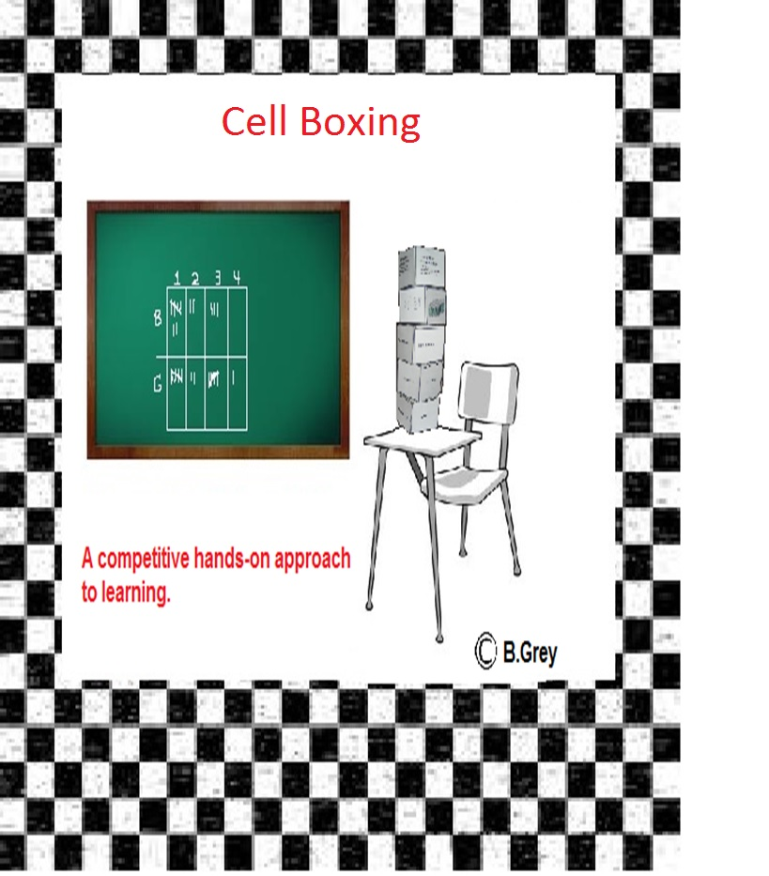

Activity 1: Cell Boxing

Teacher notes: Model this activity before asking the student to do it.

**Overview**: Students will compete against each other by keeping track of how many boxes they can match up with each organelle/part name, picture and function . Each student will keep track of their opponent’s correct answers using the score card.

1. The student keeping score should use the cell organelle with the organelle names on it to show the other student what they need to match.
2. The other student will use the other two boxes and attempt to correctly match them with the cell organelle being shown by their opponent.
3. Using the key, the student keeping score should check their opponent’s answers and record the number of correctly matched boxes. Students should continue until each player has done all 6 cell organelles. After both students complete round one they should proceed to the next round.

Example: One student (score keeper) shows “mitochondria” to their opponent. The opponent should look at each of the boxes and determine which function, picture and examples match with the organelle.

The score keeper could use the provided key to determine how many boxes were correctly identified as being mitochondria. The score keeper will record total number boxes that were correct under round 1-mitochondria. Next, the score keeper could show the remaining organelles.

Activity 2: Group competition

Teachers Note: This is a great activity for a test review. I offer homework passes to the winning group.

1. Place students in into pairs or small groups
2. Give each group one set of boxes.
3. The teacher will say the name of a cell organelle.
4. The groups will compete to correctly stack the boxes as quickly as possible. When the time is up all members of the group should put both hands up and refrain from touching the boxes until their work is checked or they will be disqualified and will not receive the point.
5. The groups with the correct answers receive one point.
   1. Note: Use a timer (5-15 seconds ,decrease the time as the students get better)
6. Note: Do not begin checking groups until the time is up and keep track of who finishes first.
7. Keep track of the points on the board.

Activity 3: Warm up or Closure

This is an excellent and quick activity to assess students. I have used this for a warm ups and closures.

1. Distribute one box to each student. (not the box with organelles on it)
2. Ask the students to hold up the side of the box that represents one the organelle that you announce.
3. The teacher should circulate the room and give the students feedback or hints.

Suggestions:

1. Read the included lesson plan to see how I have effectively used these boxes.

Constructing the boxes:

1. Print the boxes. (Note: I recommend Card Stock Paper however, it will work just fine with regular copy paper.)
2. Carefully cut out the outline of the boxes.
3. Fold the tabs that say glue here.
4. Add glue (Note: I used super glue however, clear tape would be easier but does not look as nice.)

**Tip:** Find some reliable students to help you with the construction of the boxes especially if you are doing a class set. Use card stock and they should last several years depending on the students.

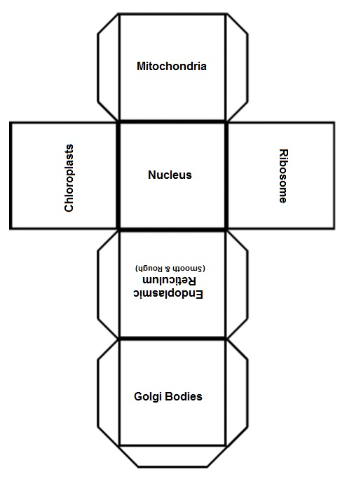

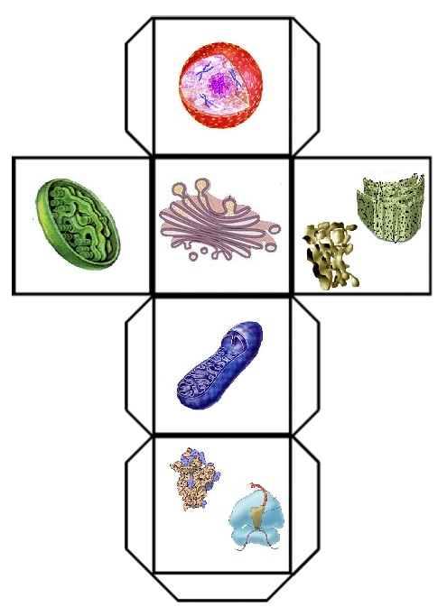

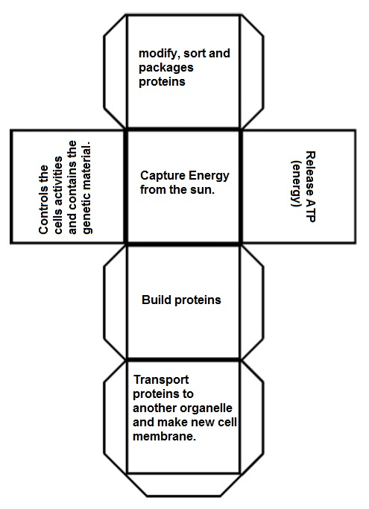

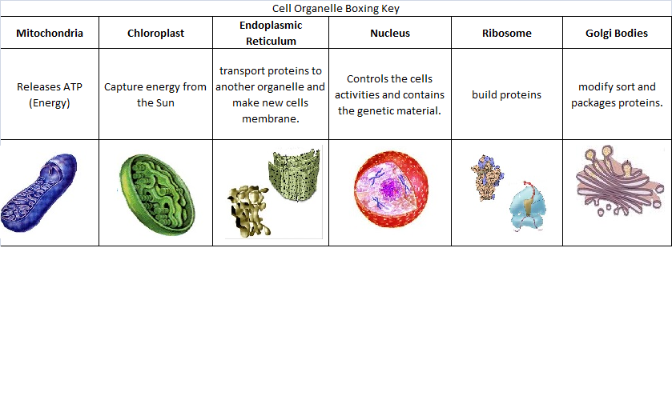

|  |  |  |  |  |  |  |  |  |
| --- | --- | --- | --- | --- | --- | --- | --- | --- |
|  | Score Card- Cell Organelle Boxing | | | | |  |  |  |
| Player 1 | **Round 1** | **Mitochondria** | **Chloroplast** | **Endoplasmic Reticulum** | **Nucleus** | **Ribosome** | **Golgi Bodies** | **Total** |
| Name: | # of correct boxes |  |  |  |  |  |  |  |
| **Round 2** | **Mitochondria** | **Chloroplast** | **Endoplasmic Reticulum** | **Nucleus** | **Ribosome** | **Golgi Bodies** | **Total** |
| # of correct boxes |  |  |  |  |  |  |  |
| **Round 3** | **Mitochondria** | **Chloroplast** | **Endoplasmic Reticulum** | **Nucleus** | **Ribosome** | **Golgi Bodies** | **Total** |
| # of correct boxes |  |  |  |  |  |  |  |
| **Round 4** | **Mitochondria** | **Chloroplast** | **Endoplasmic Reticulum** | **Nucleus** | **Ribosome** | **Golgi Bodies** | **Total** |
| # of correct boxes |  |  |  |  |  |  | Overall Score |
|  |  |  |  |  |  |  |  |  |
|  | Score Card- Cell Organelle Boxing | | | | |  |  |  |
| Player 2 | **Round 1** | **Mitochondria** | **Chloroplast** | **Endoplasmic Reticulum** | **Nucleus** | **Ribosome** | **Golgi Bodies** | **Total** |
| Name: | # of correct boxes |  |  |  |  |  |  |  |
| **Round 2** | **Mitochondria** | **Chloroplast** | **Endoplasmic Reticulum** | **Nucleus** | **Ribosome** | **Golgi Bodies** | **Total** |
| # of correct boxes |  |  |  |  |  |  |  |
| **Round 3** | **Mitochondria** | **Chloroplast** | **Endoplasmic Reticulum** | **Nucleus** | **Ribosome** | **Golgi Bodies** | **Total** |
| # of correct boxes |  |  |  |  |  |  |  |
| **Round 4** | **Mitochondria** | **Chloroplast** | **Endoplasmic Reticulum** | **Nucleus** | **Ribosome** | **Golgi Bodies** | **Total** |
| # of correct boxes |  |  |  |  |  |  | Overall Score |
|  |  |  |  |  |  |  |  |  |