Pedigree Rules
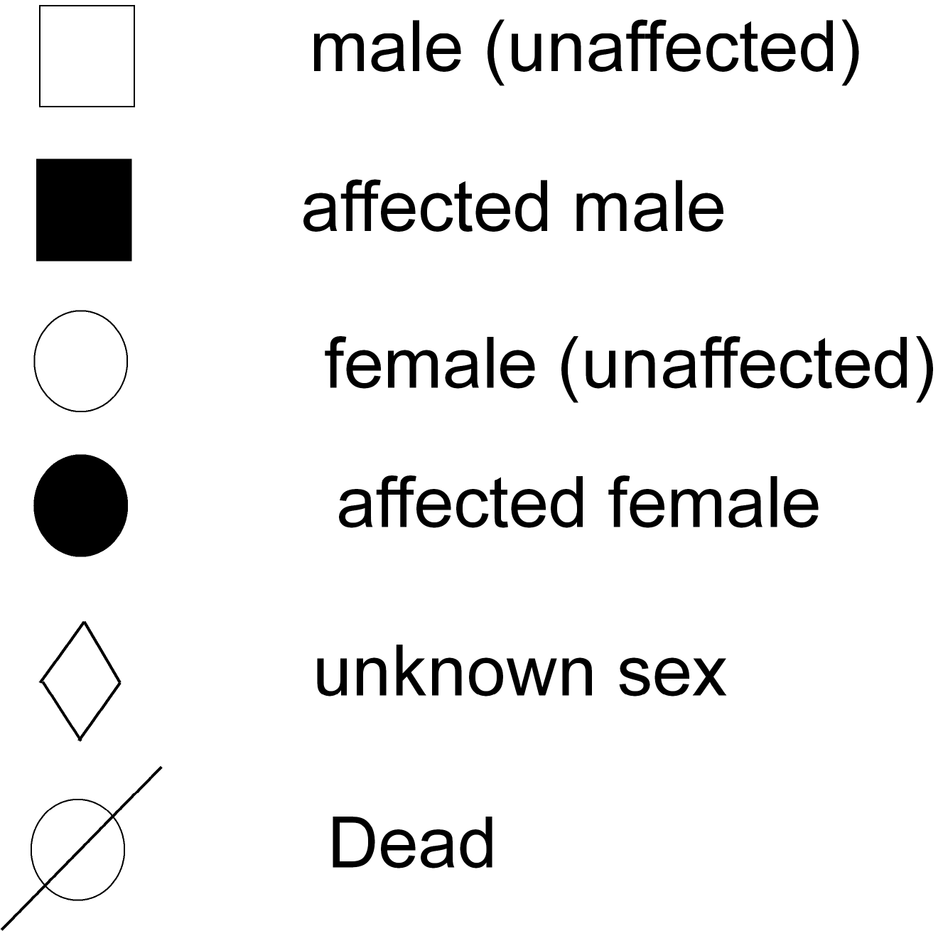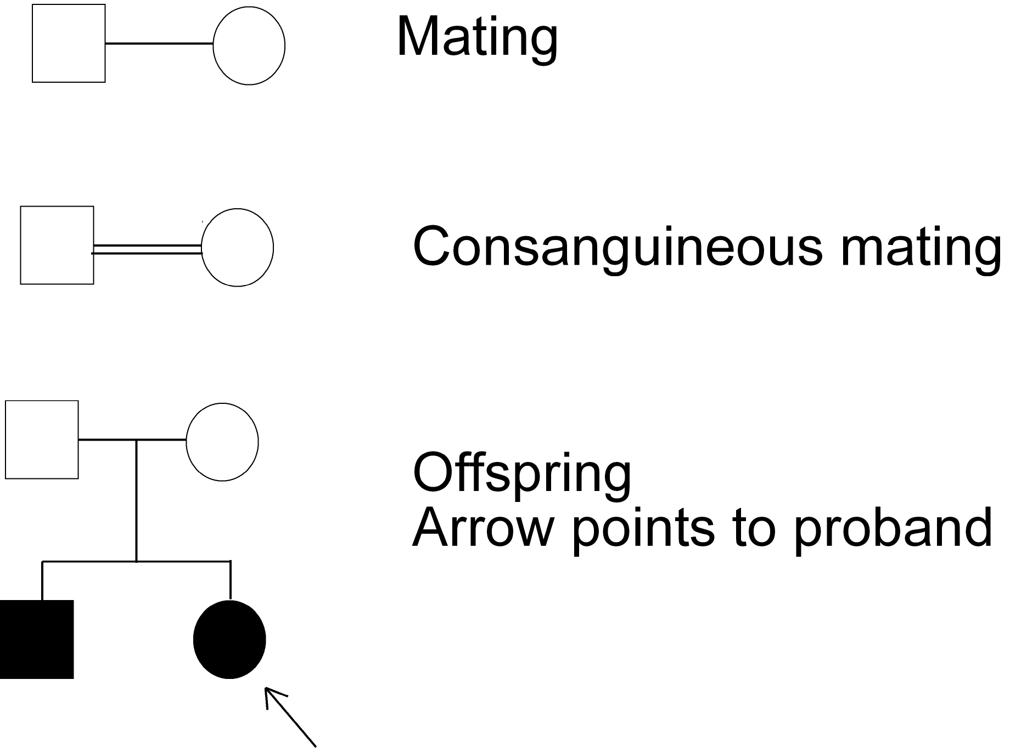
Build a Pedigree
John Jones, a green-eye man, marries Jill Smith, a blue-eyed woman. John and Jill have four green-eyed children, John Jr., Alice, Lisa and Sean. John Jr. later marries blue-eyed Pamela and they have four children: Jessica, Shari, Mary and John III. Shari and Mary both have green eyes, Jessica and John III have blue eyes. Sean marries Robin, a blue-eyed woman. Both of Robin’s parents have blue eyes as well. Sean and Robin have four children: Nicholas, Harry Donna and Sean Jr. Nicholas, Harry and Donna all have green eyes. Sean Jr. has blue eyes. Sean Jr. marries Kim and they have blue-eyed twin boys Keith and Karl. Kim herself has blue eyes but both of her parents have green eyes.
Draw a Pedigree below that traces the trait for green eyes. (Assume that green eyes is dominant to blue eyes)
- Include the genotypes for each individual in the Pedigree.
- Label the generations using Roman numerals on the left hand side.
- Shade in the individuals who show the trait that is being traces (green eyes.)

Practice Question: In humans, the allele for having feet with normal arches is dominant (A). The allele for flat feet is recessive (a). The pedigree below shows the occurrence of normal arches and flat feet in four generations of a family. In the pedigree, individuals are identified by the generation and individual numbers. For example, Individual 2 in Generation I is identified as I-2.Build a Punnet square that shows a cross between Individual. 4 and Individual 5
