Animal Cell Label & Color
Directions: Choose a color for each of the parts below and fill in the square with the color of your choice. Color the cell part to match.
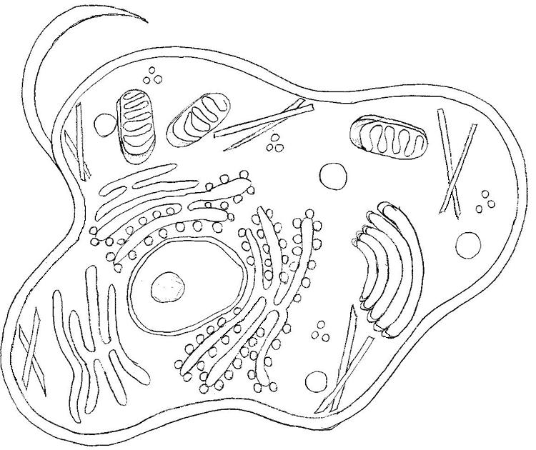

Cell Membrane |  |  | Ribosome
Cytoplasm |  |  | Smooth Endoplasmic Reticulum
Nuclear Envelope |  |  | Rough Endoplasmic Reticulum
Nucleus |  |  | Mitochondria
Nucleolus |  |  | Small Vacuole
Golgi Apparatus |  |  | Microtubules
Flagella

Plant Cell Label & Color
Directions: Choose a color for each of the parts below and fill in the square with the color of your choice. Color the cell part to match.
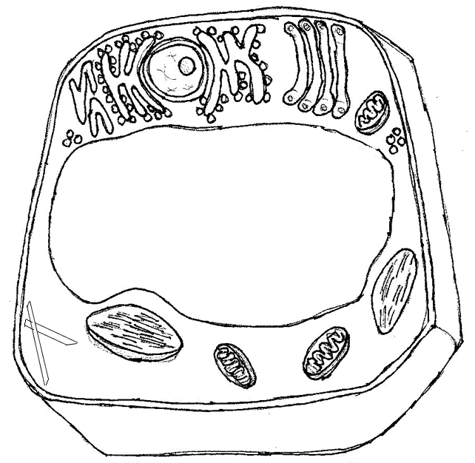

Cell Membrane |  |  | Ribosome
Cytoplasm |  |  | Smooth Endoplasmic Reticulum
Nuclear Envelope |  |  | Rough Endoplasmic Reticulum
Nucleus |  |  | Mitochondria
Nucleolus |  |  | Chloroplasts
Golgi Apparatus |  |  | Microtubules
Large Vacuole |  |  | Cell Wall

